

Southern Luzon State University College of Engineering
Computer Engineering Department

CPE24 Embedded Systems Final Term Assignment 1

Name: Dave Jhared G. Paduada Date: November 6, 2025
Section: GF
- Define, discuss and give and illustrate example of Embedded Systems Life Cycle Models. To be printed in long bond paper.
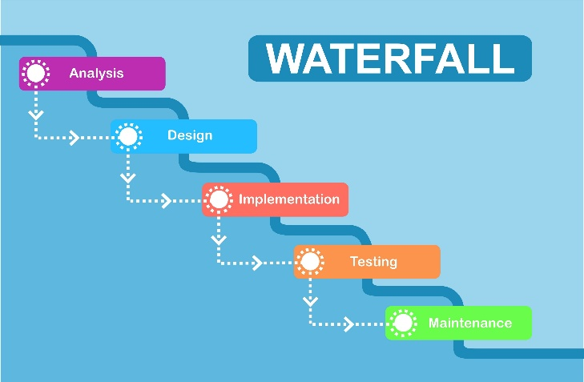
  - Waterfall model - The Waterfall Model is a linear, sequential development model. Each phase must be fully completed before the next phase can begin. It is the most traditional and straightforward model.
Discussion:
- Phases: The typical phases are: 1. Requirements, 2. System Design, 3. Implementation (Coding), 4. Testing, 5. Deployment, and 6. Maintenance.
- Pros: It is simple to understand and manage. Each phase has clear deliverables and a distinct endpoint, making it easy to track progress. It works well when requirements are well-understood and stable.
- Cons: It is highly inflexible. A change in requirements at a late stage (like during testing) is very costly and difficult to implement, as it requires going back to the design phase. Testing only happens after all implementation is complete, so bugs are found late.
- Embedded Context: This model is suitable only for very simple embedded systems where the hardware and software requirements are known perfectly upfront and are guaranteed not to change (e.g., a simple garage door opener or a basic digital thermostat).
Example: Developing a simple microwave oven controller. The requirements are fixed: e.g., three power levels, a 0-30 minute timer, a start/stop button, and a "door open" sensor. These requirements are unlikely to change, so the team can proceed sequentially from design to coding to testing.

  - V Model (Verification & Validation Model) - The V-Model is an extension of the Waterfall Model that emphasizes testing. Each development phase on the "down" side of the V is directly associated with a corresponding testing (Verification or Validation) phase on the "up" side.

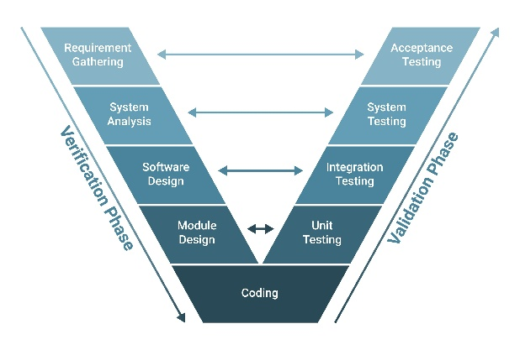
Discussion:
- Structure:
  - Left Side (Development): Requirements -> High-Level Design -> Low-Level Design -> Implementation (Coding).
  - Right Side (Testing): Unit Testing (validates Low-Level Design) -> Integration Testing (validates High-Level Design) -> System Testing (validates Requirements) -> Acceptance Testing.
- Pros: It integrates testing throughout the entire life cycle, which helps catch bugs early. It forces a clear link between what the design specifies and what the tests must check.
- Cons: Like the Waterfall model, it is still relatively rigid. If requirements change, the entire "V" (both design and test plans) needs to be updated.
- Embedded Context: This model is excellent for safety-critical embedded systems where failure is not an option and rigorous testing is required. This includes automotive (e.g., ABS, airbags), avionics (flight controls), and medical devices (e.g., pacemakers).

Example: Developing an automotive Anti-lock Braking System (ABS).
- Low-Level Design (e.g., the code for a single wheel-speed sensor module) is paired with Unit Testing.
- High-Level Design (e.g., how all wheel sensors and the brake actuator module communicate) is paired with Integration Testing.
- System Requirements (e.g., "The system shall prevent wheel lock-up on wet pavement") is paired with System Testing (on a test track).

  - Spiral Model - The Spiral Model is a risk-driven model that combines the iterative nature of prototyping with the systematic control of the Waterfall model. Development proceeds in a series of "spirals" or iterations, with each spiral focusing on risk management.
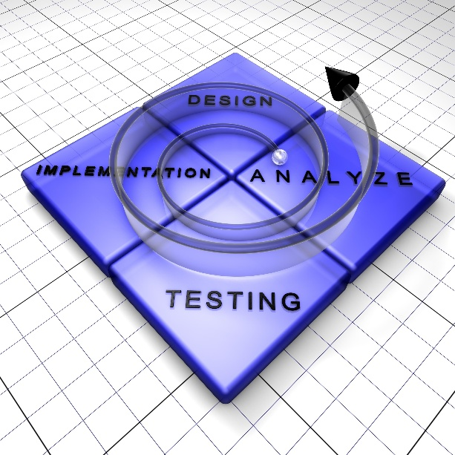

Discussion:
- Phases (per spiral): Each spiral typically consists of four main activities:
  - Planning: Determine objectives, alternatives, and constraints.
  - Risk Analysis: Identify and resolve risks. This is the most important feature of the model.
  - Engineering: Develop and test the product for that iteration (this could involve building a prototype).
  - Evaluation: The customer evaluates the output of the spiral, and plans are made for the next loop.
- Pros: It is excellent for large, complex, and high-risk projects. Risk analysis is built-in. It allows for changes and the addition of new features in later spirals.
- Cons: The model is complex to manage. It requires expertise in risk assessment, and the process can be costly and time-consuming.
- Embedded Context: Ideal for R&D-heavy embedded systems involving new, unproven hardware or complex algorithms, such as an autonomous drone's navigation system or a new type of biometric sensor.

Example: Developing a collision-avoidance system for a new autonomous drone.
- Spiral 1: Risk: Can the sensor detect obstacles? Engineering: Build a simple prototype with just the sensor (e.g., LiDAR) and a microcontroller to test detection range and accuracy.
- Spiral 2: Risk: Can the system react fast enough? Engineering: Integrate the sensor with the drone's flight controller to test a simple "stop" command.
- Spiral 3: Risk: Can the system handle multiple moving obstacles? Engineering: Develop the full avoidance algorithm.

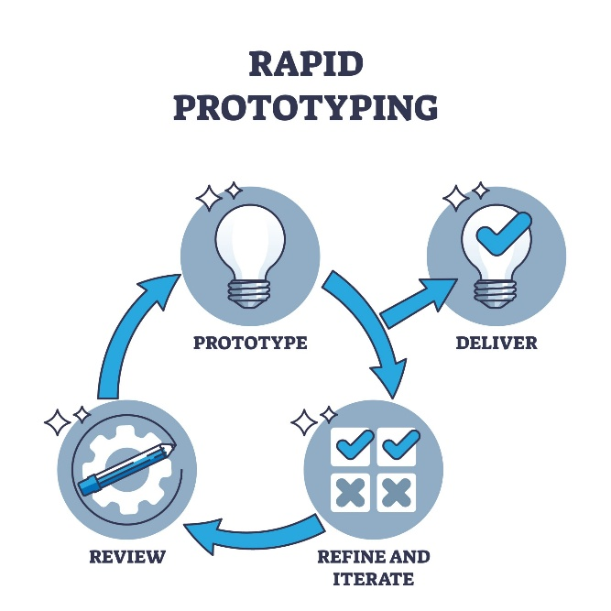
  - Rapid Prototype - The Prototyping Model focuses on quickly building a functional, but often simplified, version of the system (a "prototype"). This prototype is given to the user for feedback, which is then used to refine the requirements and the prototype itself. This process is repeated until the user is satisfied.

Discussion:
- Process: 1. Identify basic requirements, 2. Develop a quick "mock-up" or prototype, 3. Present prototype to user for feedback, 4. Revise and refine the prototype based on feedback. This cycle repeats.
- Pros: Gathers user feedback very early, which is excellent when requirements are unclear or poorly defined. It reduces the risk of building a product the user doesn't want.
- Cons: The user might see the prototype and assume the final product is almost ready, not understanding the "back-end" work still needed. It can lead to "feature creep," where the user keeps adding new requests.
- Embedded Context: This is extremely valuable for the Human-Machine Interface (HMI) of an embedded system. It's much easier to refine a user interface (like a touchscreen or button layout) by letting a user try it, rather than just describing it on paper.

Example: Designing the user interface for a new smart home control panel.
- Prototype 1: A simple simulation on a computer screen showing the button layout. User Feedback: "The icons for 'lights' and 'fans' are confusing."
- Prototype 2: A functional prototype on the actual touchscreen hardware with basic controls. User Feedback: "The 'confirm' button is too small, and I want a 'schedule' feature."
- This feedback cycle continues until the UI is intuitive and meets the user's needs, before the team finalizes the underlying control software.

  - System Specification vs System Requirements

Definitions:
- System Requirements: This document defines WHAT the system must do. It describes the functions, features, and constraints from the user's perspective. It focuses on the problem to be solved.
- System Specification: This document defines HOW the system will be built to meet those requirements. It is a detailed technical description of the system's design, including hardware components, software modules, interfaces, and performance benchmarks.

Comparison Example: Imagine developing an embedded medical heart rate monitor
Concept | System Requirement (The "What") | System Specification (The "How")
Function | "The device must accurately measure and display the patient's heart rate in beats per minute (BPM)." | "The system will use a MAX30102 sensor module to capture photoplethysmography (PPG) signals. The raw signal will be processed by the MCU using a 4th-order Butterworth filter and a peak-detection algorithm to calculate BPM."
Alert | "The device must sound an audible alarm if the heart rate drops below 50 BPM or exceeds 120 BPM." | "The alarm condition will be triggered by a software comparator. Upon trigger, digital pin D5 will send a 3.8kHz PWM signal to a 5V piezoelectric buzzer (Part #XYZ-001) until the alarm is acknowledged."
Power | "The device must operate for at least 24 hours on a single battery charge." | "The system will be powered by a 3.7V, 1200mAh Li-Po battery (Part #ABC-456). The ATmega328 MCU will be kept in 'deep-sleep' mode and woken by an interrupt every 250ms to take a reading, minimizing power consumption."

  - Functional model vs Architectural model
Definitions:
- Functional Model: This model describes the behavior and logic of the system. It focuses on the functions the system performs, the processes it follows, and the flow of data through the system. It answers: "What does it do?" (e.L., Data Flow Diagrams).
- Architectural Model: This model describes the structure and organization of the system. It defines the main hardware and software components and the interfaces and relationships between them. It is the system's high-level blueprint. It answers: "What is it made of?" (e.L., Block Diagrams).
Comparison Example: Imagine a smart irrigation system.
- Functional Model: This would be shown as a process or data flow diagram.
  - Read_Soil_Moisture_Sensor()
  - Check_Moisture_Level() -> Is it below the Threshold?
  - If YES: a. Send_Signal_to_Cloud() b. Receive_Watering_Schedule() (from cloud/app) c. Activate_Water_Valve()
  - If NO: a. Go_to_Sleep()
  - Wait_for_Next_Cycle()
- Architectural Model: This would be shown as a block diagram of physical and software components.

